EXPERIMENT 10 — Views and Indexes
AIM:
To study and implement SQL Views and Indexes for efficient data access and management.
PROCEDURE:
- Create the SHOWROOM_VEHICLE table and insert vehicle records.
- Create a view V1 containing VehicleID, VehicleName, and Price.
- Display the view.
- Insert a record through the view and verify it in the original table.
- Delete the inserted record through the view.
- Create an index on the Price column.
- Retrieve vehicles with prices above ₹14,50,000.
- Display and drop the price index.
- Create an index on VehicleID.
- Retrieve a vehicle using its VehicleID.
- Display and drop the index.
OUT: 1
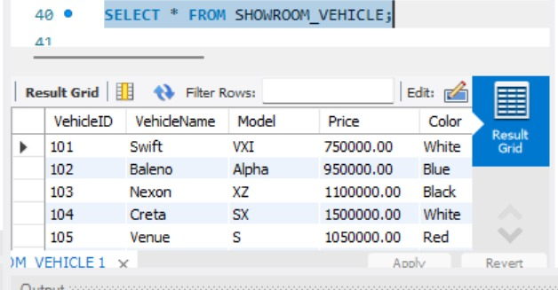
OUT: 2
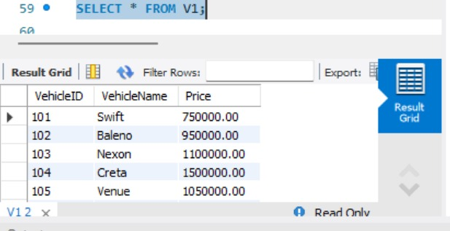
OUT: 3
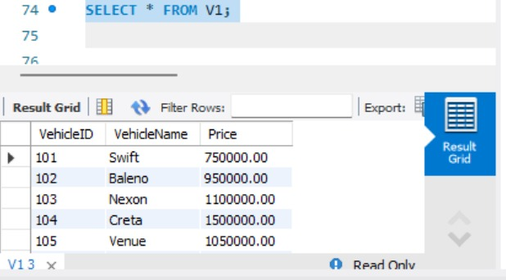
OUT: 4
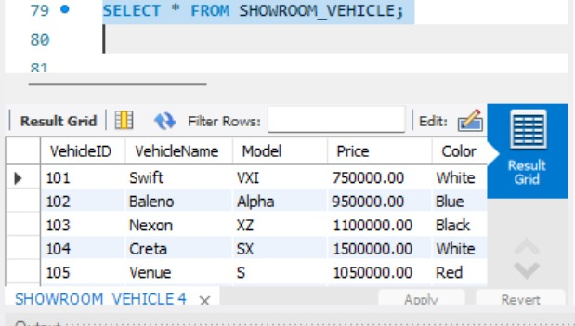
OUT: 5
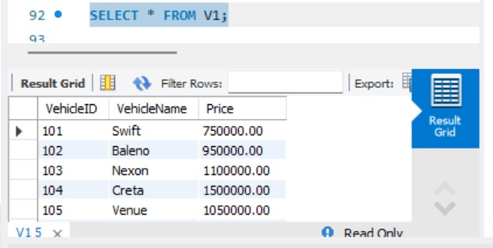
OUT: 6
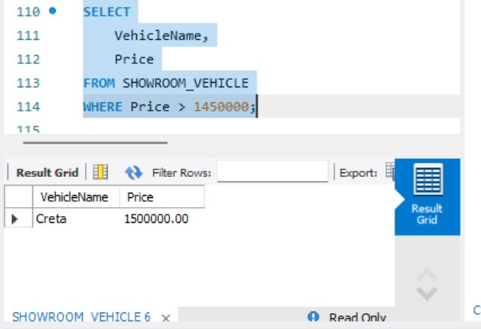
OUT: 7
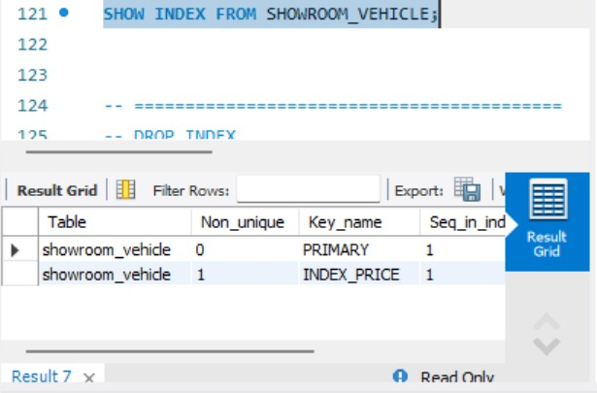
OUT: 8
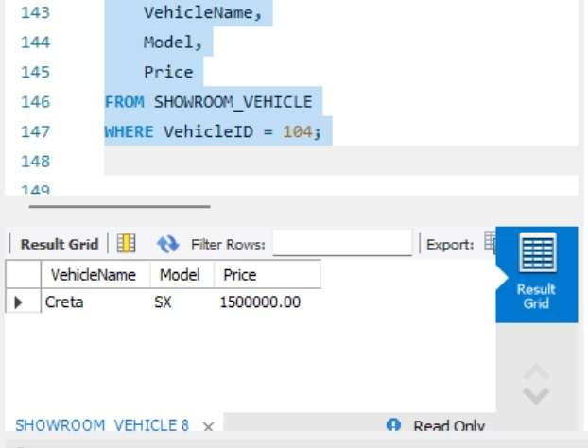
OUT: 9
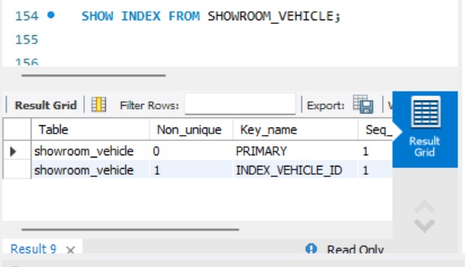
OUT: 10
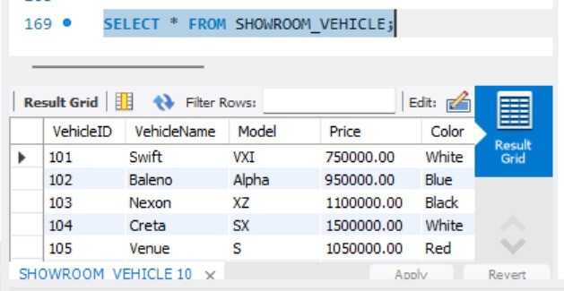

QUERY:
USE AUTOHUB_SHOWROOM;
-- ==========================================
-- 1. CREATE SHOWROOM TABLE
-- ==========================================
DROP TABLE IF EXISTS SHOWROOM_VEHICLE;
CREATE TABLE SHOWROOM_VEHICLE
(
VehicleID INT PRIMARY KEY,
VehicleName VARCHAR(30),
Model VARCHAR(20),
Price DECIMAL(10,2),
Color VARCHAR(20),
FuelType VARCHAR(20)
);
-- ==========================================
-- 2. INSERT 8 SHOWROOM RECORDS
-- ==========================================
INSERT INTO SHOWROOM_VEHICLE
(VehicleID, VehicleName, Model, Price, Color, FuelType)
VALUES
(101, 'Swift', 'VXI', 750000, 'White', 'Petrol'),
(102, 'Baleno', 'Alpha', 950000, 'Blue', 'Petrol'),
(103, 'Nexon', 'XZ', 1100000, 'Black', 'Diesel'),
(104, 'Creta', 'SX', 1500000, 'White', 'Diesel'),
(105, 'Venue', 'S', 1050000, 'Red', 'Petrol'),
(106, 'i20', 'Sportz', 900000, 'Grey', 'Petrol'),
(107, 'Verna', 'SX', 1400000, 'Black', 'Petrol'),
(108, 'Punch', 'Adventure', 850000, 'Blue', 'Petrol');
-- Display original records
SELECT * FROM SHOWROOM_VEHICLE;
-- ==========================================
-- PROGRAM 1 – CREATE VIEW
-- ==========================================
DROP VIEW IF EXISTS V1;
CREATE VIEW V1 AS
SELECT
VehicleID,
VehicleName,
Price
FROM SHOWROOM_VEHICLE;
-- Display VIEW
SELECT * FROM V1;
-- ==========================================
-- INSERT RECORD THROUGH VIEW
-- ==========================================
INSERT INTO V1
(VehicleID, VehicleName, Price)
VALUES
(109, 'Fronx', 900000);
-- Check inserted record
SELECT * FROM V1;
-- Check original table
SELECT * FROM SHOWROOM_VEHICLE;
-- ==========================================
-- DELETE RECORD THROUGH VIEW
-- ==========================================
DELETE FROM V1
WHERE VehicleID = 109;
-- Check VIEW after DELETE
SELECT * FROM V1;
-- ==========================================
-- PROGRAM 2 – CREATE INDEX ON PRICE
-- ==========================================
DROP INDEX IF EXISTS INDEX_PRICE
ON SHOWROOM_VEHICLE;
CREATE INDEX INDEX_PRICE
ON SHOWROOM_VEHICLE(Price);
-- ==========================================
-- DISPLAY VEHICLES ABOVE 1450000
-- ==========================================
SELECT
VehicleName,
Price
FROM SHOWROOM_VEHICLE
WHERE Price > 1450000;
-- ==========================================
-- SHOW INDEX
-- ==========================================
SHOW INDEX FROM SHOWROOM_VEHICLE;
-- ==========================================
-- DROP INDEX
-- ==========================================
DROP INDEX INDEX_PRICE
ON SHOWROOM_VEHICLE;
-- ==========================================
-- PROGRAM 3 – INDEX ON VEHICLE ID
-- ==========================================
CREATE INDEX INDEX_VEHICLE_ID
ON SHOWROOM_VEHICLE(VehicleID);
-- Find vehicle with VehicleID = 104
SELECT
VehicleName,
Model,
Price
FROM SHOWROOM_VEHICLE
WHERE VehicleID = 104;
-- ==========================================
-- SHOW INDEX
-- ==========================================
SHOW INDEX FROM SHOWROOM_VEHICLE;
-- ==========================================
-- DROP INDEX
-- ==========================================
DROP INDEX INDEX_VEHICLE_ID
ON SHOWROOM_VEHICLE;
-- ==========================================
-- FINAL DISPLAY
-- ==========================================
SELECT * FROM SHOWROOM_VEHICLE;
RESULT:
Thus, views and indexes were successfully created, used, verified, and removed from the database.

